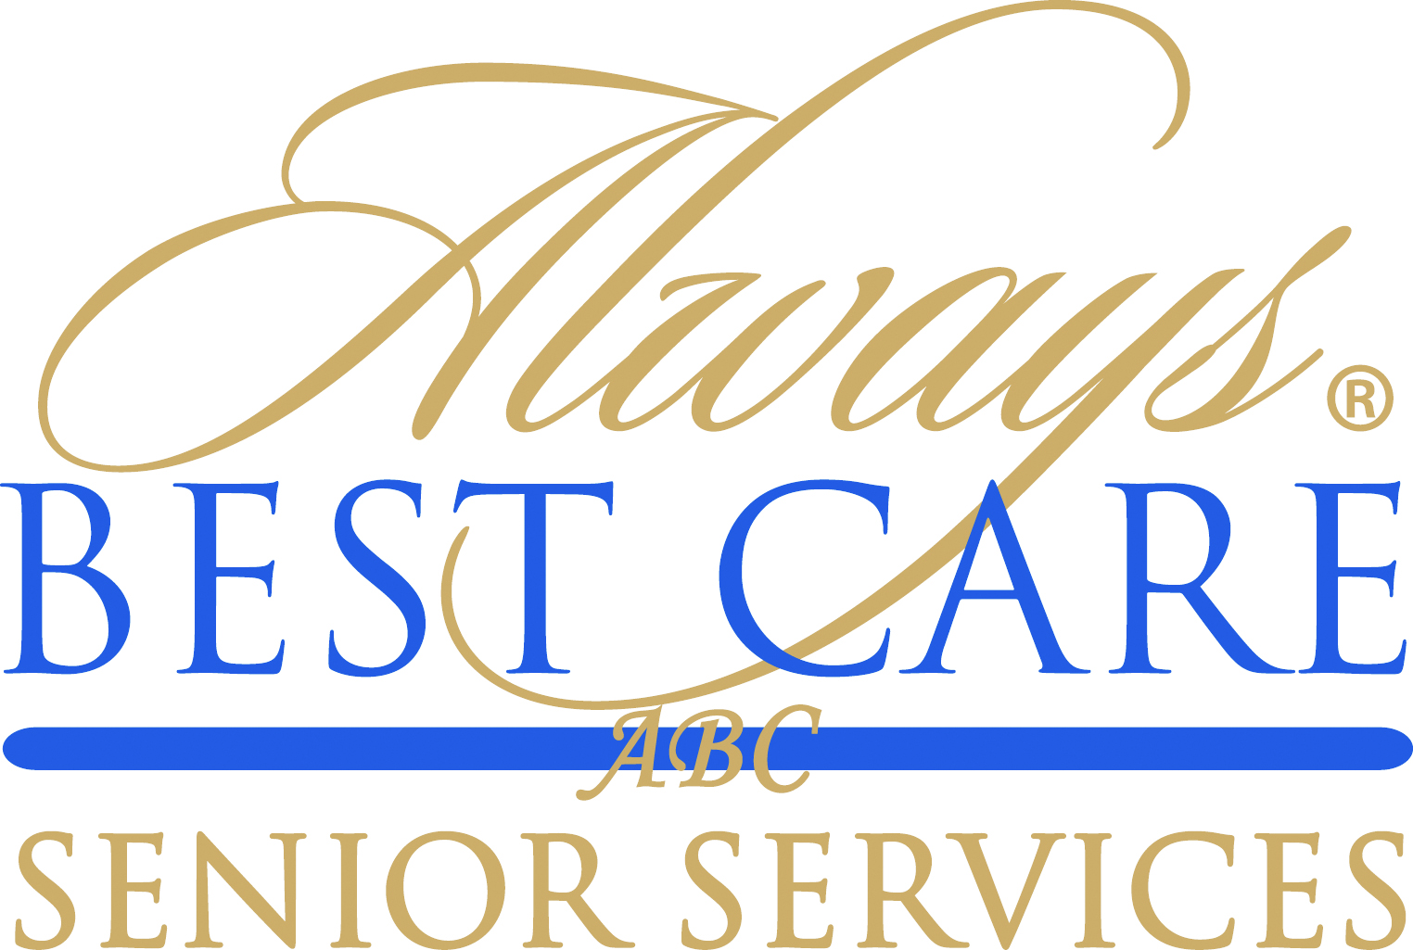

FOR IMMEDIATE RELEASE CONTACT:
August 17, 2015 Larry Miramontes
lmiramontes@abc-seniors.com
916-596-1825

Motivational Expert Chip Eichelberger Keynotes Always Best Care international conference

Roseville, CA (August 17, 2015) – Chip Eichelberger, renowned motivational speaker, delivered the keynote address at Always Best Care Senior Service’s 4th International Conference in San Antonio, Texas. Mr. Eichelberger delivered “Get Switched On,” inspiring conference attendees on how to reenergize their work and their lives.
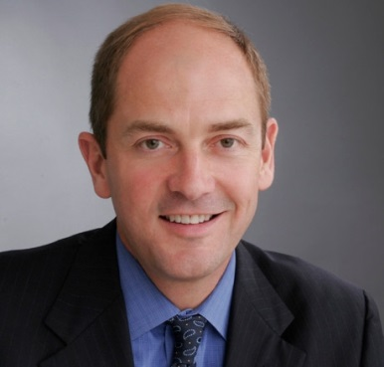
Mr. Eichelberger graduated from the University of Oregon in 1983 from the College of Business Administration. In 1988, he joined the world-renowned Tony Robbins organization, where he proved himself as Sales Leader of the Year each year on the road. He mastered telemarketing and group presentation sales. He hired, trained and led sales teams throughout the United States and was Sales Manager of the Year before leading the charge to build the brand in Australia and the United Kingdom as his international point-man.

After five years with Tony Robbins, Chip launched his own motivational-speaking career in 1993. He has since been selected to "switch on" over 975 events for companies and associations such as Ford, Hyatt, Wells Fargo, Proctor & Gamble, Exxon, NADA and many others.

Always Best Care is one of the nation’s leading providers of non-medical in-home care, assisted living placement services and skilled home health care. The company delivers its services through an international network of more than 200 independently owned and operated franchise territories throughout the United States and Canada.
For information on Always Best Care franchise opportunities, call toll-free 1-855-430-CARE (2273), send an email to franchisesales@abc-seniors.com, or visit www.franchisewithalwaysbestcare.com.
# # #

About Always Best Care
Founded in 1996, Always Best Care Senior Services is based on the belief that having the right people for the right level of care means peace of mind for the client and family. Always Best Care assists seniors with a wide range of illnesses and personal needs, and currently provides more than 4 million hours of care every year. Franchise opportunities are available to individuals interested in leveraging the company’s clear strategy and proven track record for delivering affordable, dependable service to seniors in their local areas.

By working with case managers, social workers, discharge planners, doctors, and families, Always Best Care franchise owners provide affordable, comprehensive solutions that can be specifically matched to meet a client’s particular physical or social needs. The hallmark services of the Always Best Care business portfolio include non-medical in-home care and assisted living finder and referral services, with skilled home health care now being phased in throughout the country. For more information, visit www.AlwaysBestCare.com. For franchise opportunities, visit www.FranchiseWithAlwaysBestCare.com.

Always Best Care also offers Free ABC Rx cards, which provide discounts of up to 65 percent off the cost of prescription drugs at more than 59,000 pharmacies across the USA, and have saved consumers more than $500,000 since its inception. This service is offered at no cost to the users, there are no deductibles, no waiting periods, no pre-existing exclusions, and no eligibility requirements -- everyone can use the card (even family members and pets!). The Free ABC Rx card covers many medications that Medicare Part D and regular insurance often do not. To download a free card, visit www.FreeABCRx.com.

Another exclusive program offered by Always Best Care is Always in Touch, a telephone reassurance program that provides a daily phone call to seniors and disabled adults who are living alone and have limited contact with the outside world. Always in Touch is the only absolutely free national telephone reassurance program of its kind anywhere in the USA and Canada. For more information on Always in Touch, or to request an application, visit www.Always-in-Touch.com.

